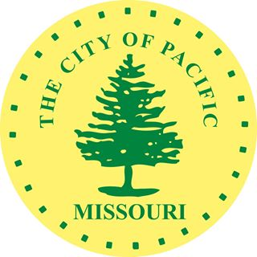
The City of Pacific, Missouri is seeking qualified candidates for a position with the Pacific Public Works Department. This position will work primarily with the City's Water and Wastewater Department but will also assist with the City's Street Department and City Parks and will perform other duties as assigned.
The ideal candidate will have a background in water distribution and/or treatment and/or wastewater treatment and/or collection systems. Including utility work and experience and proficiency in operating a wide variety of vehicles, light and heavy equipment, hand tools, specialized equipment, plant/treatment facility including pumps, motors and chemical feeding.
The ideal candidate will have excellent verbal and written communications skills, and be able to work well with supervisors, fellow employees and the general public. The candidate will have knowledge and understanding of safe work practices and standards, and a strong commitment to public service. Candidates must be able to work occasional evenings, weekends and holidays, and be able to respond to the job site within 30 minutes if called in an emergency.
Minimum qualifications include a high school diploma, GED, or equivalent. The ability to work varying shifts, including some weekends, holidays and overtime work as needed. The selected candidate must possess a Class A CDL with air brakes and tanker endorsement or have the ability to obtain one within six months of hire; must be able to perform physical manual labor, including lifting and carrying 50 pounds or more; must be able to work outdoors in occasional adverse weather conditions; and perform other physical labor as may be required.
The starting pay for this position is $ 19.50 Per hour, depending on experience and qualifications according to the pay matrix. After a 90-day probationary period and CDL is obtained, the pay rate will increase to $22.00 Per hour for Water/Wastewater Department Operator Apprentice position. The City of Pacific offers an excellent benefits package, including health, dental and vision insurance, paid vacation and other leave benefits, and the Missouri LAGERS defined benefit pension plan. The successful candidate must produce documentation of their status to be lawfully employed in the United States, and must pass a criminal background check, drug test and other pre-employment screenings as may be required, prior to employment with the City of Pacific.
Prospective applicants should send a completed application, including resume and cover letter, to the City of Pacific, 300 Hoven Drive, Pacific, MO 63069, attn. City Clerk. Applications may be sent by email to kbarfield@pacificmissouri.com.

