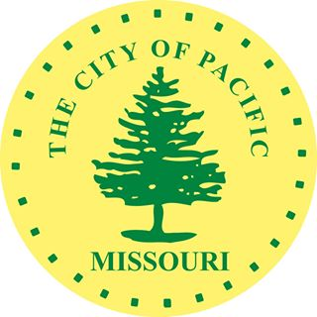
POSITION DESCRIPTION
Position Title: Museum and Event Team Member

POSITION SUMMARY
The part time Museum and Event Team Member will run the day-to-day operations at the Red Cedar Inn. The team member will perform a variety of tasks from administrative, technical, organizing, researching, cleaning, and welcoming those to the Red Cedar Inn. Other tasks will include the setup, execution, and tear down of events at Red Cedar Inn and for City events. Must be willing and able to work weekends and occasional evenings.

ESSENTIAL DUTIES AND RESPONSIBILITIES
The Team Member is directly responsible for the following tasks and duties:

- Daily operation of the Red Cedar Inn Welcome Center and Museum, including opening and closing responsibilities.
- Greeting and helping all guests who visit Red Cedar Inn. Working front desk, including POS system.
- Talking to guests about the history of Pacific, history of Route 66, along with letting guests know all the tourism and activities taking place in the area.
- Help with research for guests, genealogy, and upcoming exhibits.
- Helping stock and sell gift shop/concession merchandise.
- Help with social media, advertising, or website. Help with all marketing tasks.
- Provides guidance and help to the volunteers.
- Interact and help within the Children’s Museum.
- Help setup, execute, and tear down events at the Red Cedar and other events in the City of Pacific.
- Provide support to the activities of the Meramec Valley Historical Society and Tourism Commission.
- Keeping Red Cedar inside and out clean.
- Performs other duties as may be assigned.

The Team Member works in cooperation with the Director of Tourism on the following:
- Assists with the setting up and removal of exhibits.
- May assist with preparing and planning events at Red Cedar and in the City of Pacific.

SUPERVISION RECEIVED
Works under the Director of Tourism.

MINIMUM QUALIFICATIONS
Must be 18 years old.
Possess a valid Missouri’s Driver’s License.
Self-motivated/work alone at times.
Must be energetic.
Must be able to work weekends and some evenings/nights.
Must be able to lift up to 40lbs.
Have basic computer and phone skills, must be able to work with a POS system and money.
Must be a United States Citizen.

NECESSARY KNOWLEDGE, SKILLS AND ABILITIES:
Ability to communicate effectively, orally and in writing, with employees, consultants, other governmental agency representatives, City officials and the general public; ability to conduct necessary research; ability to use computers and computer software programs typical in a business setting, and ability to use mobile phone and data devices (smartphones) in a business setting.

PHYSICAL DEMANDS/ WORK ENVIRONMENT
The Staff Member is required to operate a computer, phone and other office equipment; must be able to stand or sit for extended periods of time; must be able to converse with and exchange information with co-workers and the general public; must be able to observe, assess and detect defects in City vehicles, equipment and infrastructure.

The Team Member works primarily in an indoor environment and is occasionally will work outdoors exposed to heat/ cold, wet / humid, and dry/ arid conditions.

